REPUBLIC OF CAMEROON
Peace - work - Fatherland
MINISTRY OF HIGHER EDUCATION

REGIONAL DELEGATION OF CENTER

PKFokam Institute of Excellence

Dignity - Faith – Responsibility
P.O.BOX 11646 Yaoundé – Cameroon
RÉPUBLIQUE DU CAMEROUN
Paix - travail – Patrie
MINISTÈRE DE L’ENSEIGNEMENT SUPÉRIEUR

DÉLÉGATION REGIONALE DU CENTRE

PKFokam Institute of Excellence

Dignité - Foi – Responsabilité
P.O. Box 11646 Yaoundé – Cameroun

Project Progress Report
WIGMS (Wedding Invitation & Gift Management System)

Course | C Programming Academic Year 2025-2026
Institution | PKFIE Pkfokam Institute of Excellence
Lecturer | Mbietieu Amos Mb.
Report Type | Module Implementation Report
Files Covered | types.h | ui.h | ui.c
Language | C (Modular Architecture)
Date | 13 March 2026

Group Members | Participation
Pettang Feumba Roddy Alann | 20%
Tiofack Kaze Franck | 20%
Mep Meku Audrey | 20%
Tamo Taboum Israel | 20%
Djatche Raziel Steevi | 20%

LECTURER: Mr. mbieteu amos mb.
DATE: Friday, 3th April 2026

Introduction
This is the second weekly progress report for the WIGMS (Wedding Invitation and Gift Management System) project. Report 1 documented the GitHub repository setup, the shared types.h library, Module 1 (Person Management), and Module 2 (Category Management). This report continues from where Report 1 ended and documents the implementation of Module 3 (Priority Management DPR Merge Sort), Module 4 (Gift Management with file persistence), and Module 5 (Graphical User Interface using the GTK+ 3.0 library). It also presents the brainstorming and initial implementation of three additional modules proposed to extend the system: Module 6 (Parking Management), Module 7 (Meal and Table Seating), and Module 8 (Event Timeline and Schedule).

3. Module 3; Priority Management (DPR Merge Sort)

3.1 Objectives
The main objectives of Module 3 are:
- Implement the DPR (Divide-Process-Recombine) algorithmic paradigm on the category linked list
- Sort guests within each category by age using insertion sort on the small fixed-size array
- Sort guests by social class priority (VIP first, then Family, then Friend, then Other)
- Apply Merge Sort to the category linked list itself, ordering categories by guest count

3.2 What Is DPR?
DPR stands for Divide – Process – Recombine. It is the academic name given in this project to the Merge Sort algorithm. The algorithm operates in three recursive steps:
Step | Action | Function
DIVIDE | Find the middle of the linked list and split it into two halves | get_middle() using Floyd tortoise & hare
PROCESS | Recursively sort both halves independently | merge_sort_internal() calling itself
RECOMBINE | Merge the two sorted halves into one sorted list | merge() comparing heads one by one

3.3 Why Merge Sort for a Linked List?
Merge Sort is the ideal algorithm for linked lists because it does not require random access by index (which arrays have but linked lists do not). It achieves O(n log n) time complexity in all cases and is stable, meaning equal elements preserve their original relative order. Bubble sort, used in Module 2 for a simpler sort, has O(n²) complexity and would be too slow for large guest lists.

3.4 File Structure
File | Role
include/priority.h | Header function declarations and include guard
src/priority.c | Implementation all DPR functions

3.5 Key Functions

3.5.1 get_middle() Floyd's Tortoise & Hare
This function finds the middle node of the linked list in a single pass using two pointers: slow moves one step at a time and fast moves two steps at a time. When fast reaches the end, slow is at the midpoint. This avoids counting the list length first, saving an extra traversal.

3.5.2 merge() The Recombine Step
The merge function receives two already-sorted sub-lists and produces one combined sorted list. It compares the heads of each sub-list and attaches the smaller one to the result, then recurses with the remaining nodes. When one sub-list is exhausted, the remaining nodes of the other are appended directly.

3.5.3 prioritize_by_age() and prioritize_by_social_class()
These functions sort the guests[] array inside each Category node. Because the array holds at most 4 elements, insertion sort is used it is faster than merge sort for very small arrays due to lower overhead. The class_rank() helper maps social class strings to integer priority values: VIP=1, Family=2, Friend=3, Other=4.

3.6 Step-by-Step Implementation Procedure
STEP 1 Create priority.h
Create include/priority.h. Add the include guard (#ifndef PRIORITY_H / #define PRIORITY_H / #endif). Declare the three public functions: priority_sort_by_age(), priority_sort_by_class(), priority_merge_sort_categories(). Mark internal helpers as static in priority.c so they are invisible outside the file.
STEP 2 Implement get_middle()
In src/priority.c, implement get_middle() with the slow/fast pointer technique described above. Test with a manually built 5-node list and verify slow lands on node 3.
STEP 3 Implement merge()
Implement the merge() function with the by_age flag controlling which field is used for comparison. Test by creating two pre-sorted 3-node sub-lists and verifying the merged result is in order.
STEP 4 Implement merge_sort_internal()
Implement the recursive DPR function: find middle, set mid->next = NULL to cut the list, recursively sort both halves, merge results. Test with a fully unsorted 6-node list.
STEP 5 Implement insertion sort for guests
Implement priority_sort_by_age() and priority_sort_by_class() using insertion sort on the fixed guests[4] array inside each node.
STEP 6 Commit to GitHub
git add include/priority.h src/priority.c && git commit -m 'Module 3: DPR Merge Sort complete' && git push origin module3-priority
3.7 GitHub Contribution
git checkout -b module3-priority
git add include/priority.h src/priority.c
git commit -m "Module 3: implemented DPR Merge Sort sort by age, class, guest count"
git push origin module3-priority

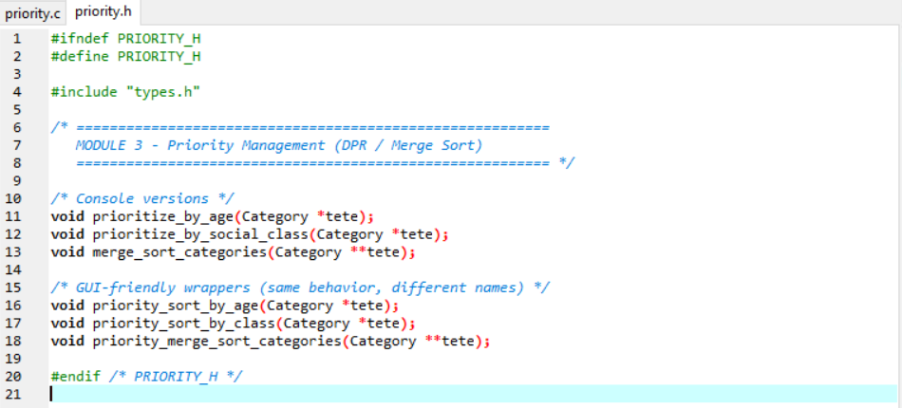
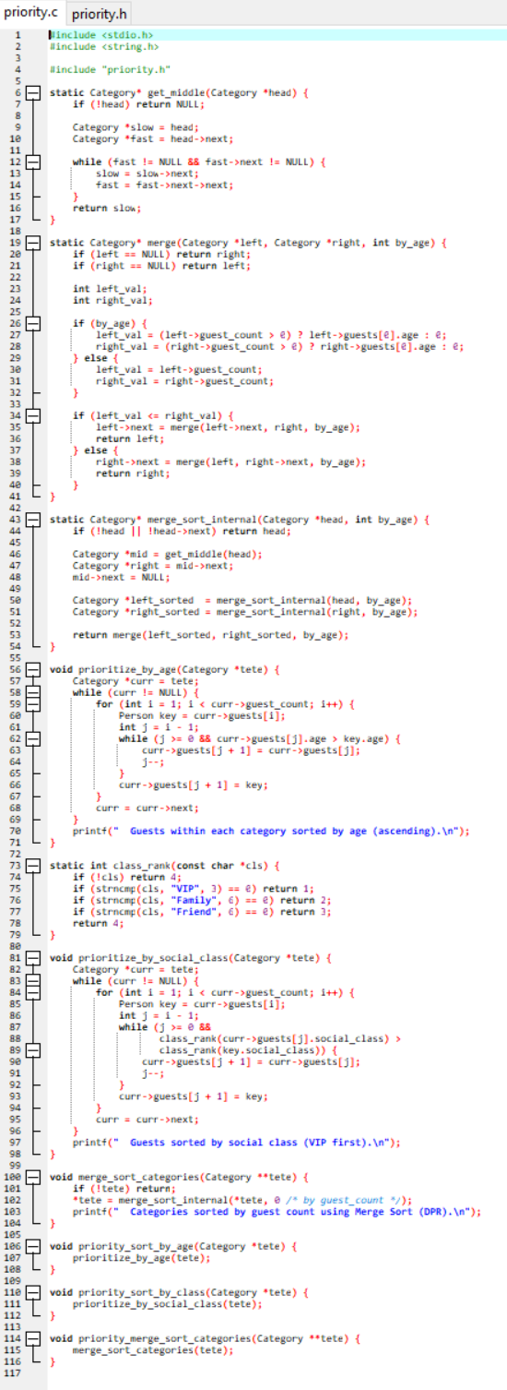
4. Module 4: Gift Management

4.1 Objectives
- Register gifts linked to specific guests by guest_id
- Display all gifts with their monetary value in FCFA
- Update and delete gifts by gift_id
- Calculate the total gift value for the entire wedding
- Save gifts to a binary file on disk so data survives program restarts
- Load gifts automatically from the binary file at startup

4.2 Data Structure
Module 4 uses a fixed-size array of Gift structs rather than a linked list. This choice is appropriate because gifts are frequently accessed by index, the maximum count is bounded (MAX_GIFTS = 200), and the flat array structure makes binary file I/O trivially simple one fwrite call writes all gifts at once.
typedef struct {
int gift_id;
char name[100];
float value; /* in FCFA */
int guest_id; /* foreign key links to a guest */
} Gift;

#define MAX_GIFTS 200

4.3 File Persistence, Binary I/O
The most technically distinctive feature of Module 4 is binary file persistence. When the program exits, all RAM is cleared. To keep gift data between sessions, the gifts array is written to a .dat file using fwrite() and read back with fread() at the next startup.
Function | Mode | What It Does
gift_save() | fopen("wb") write binary | Writes the integer count as a header, then writes all Gift structs in one fwrite() call
gift_load() | fopen("rb") read binary | Reads the count header first, then reads exactly that many Gift structs back into the array

4.4 Array Delete Shift Pattern
Because arrays do not support true deletion, removing a gift at index i requires shifting every element after it one position to the left, then decrementing the count. The last element is effectively orphaned beyond the active range and will be overwritten by the next insertion.

4.5 Step-by-Step Implementation Procedure
STEP 1 Create gift.h
Write include/gift.h with the Gift struct, MAX_GIFTS macro, extern gift_id_counter, and all function declarations.
STEP 2 Implement CRUD functions
In src/gift.c implement gift_register() (array append with bounds check), gift_delete() (array shift), gift_update() (linear search then modify), and gift_total_value() (accumulator loop).
STEP 3 Implement file I/O
Implement gift_save() and gift_load() exactly as shown above. Test by saving 3 gifts, closing the program in Dev-C++, running again, and verifying the 3 gifts are reloaded.
STEP 4 Integrate in main.c
Call gift_load() at program startup before the menu loop. Call gift_save() before program exit.
STEP 5 Test persistence
Add 5 gifts, close the program, reopen, verify all 5 reload correctly and gift IDs continue from where they left off.
STEP 6 Commit to GitHub
git add include/gift.h src/gift.c && git commit -m 'Module 4: Gift CRUD + binary file persistence' && git push origin module4-gifts
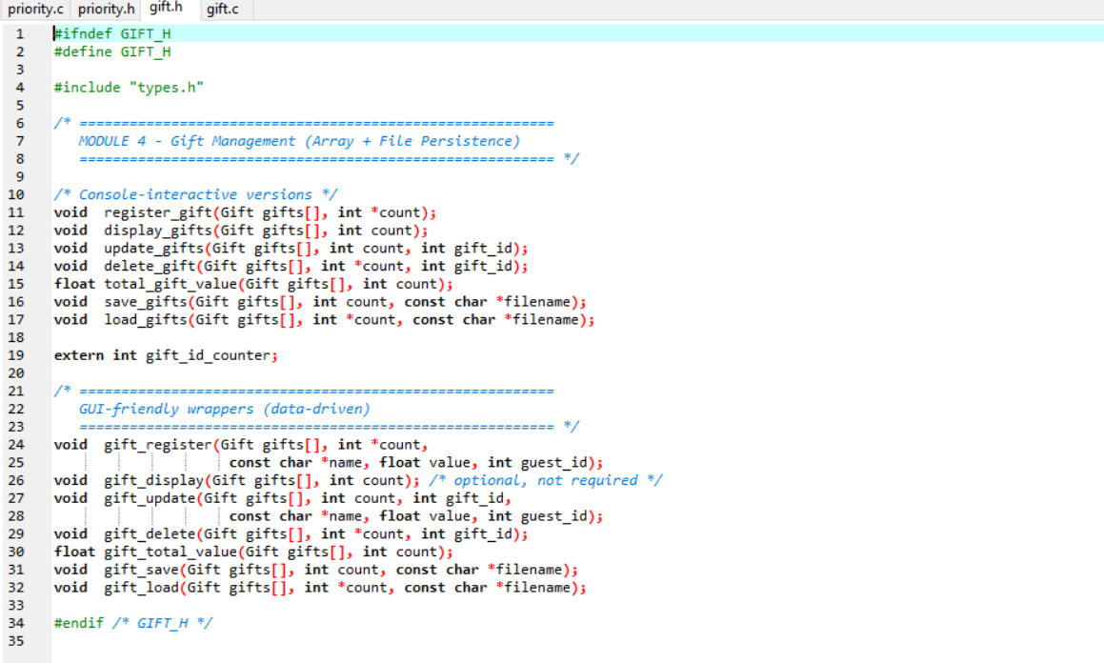

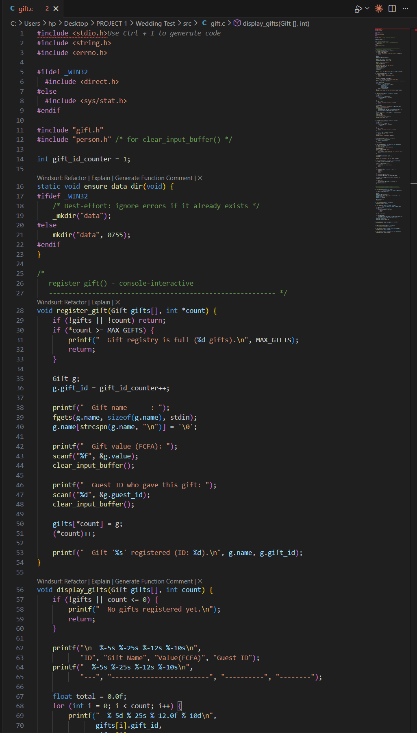

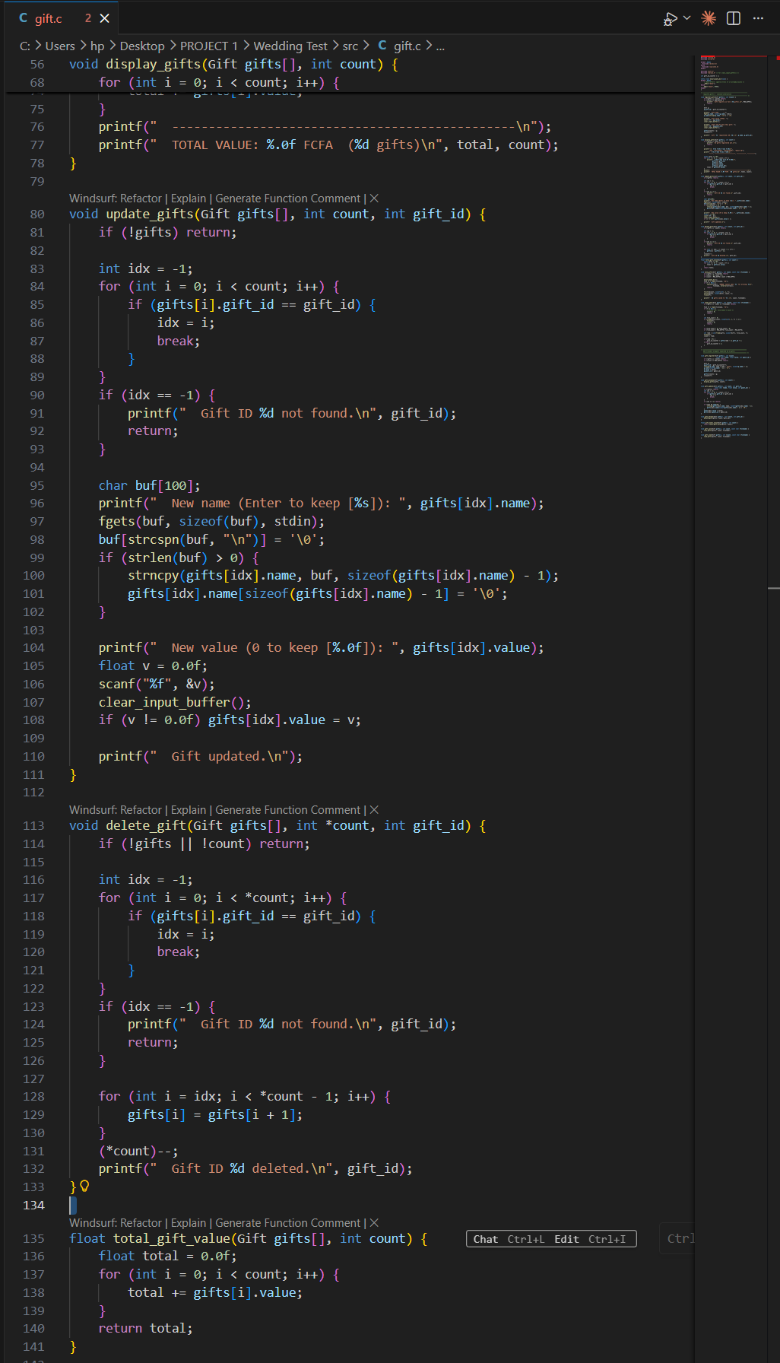

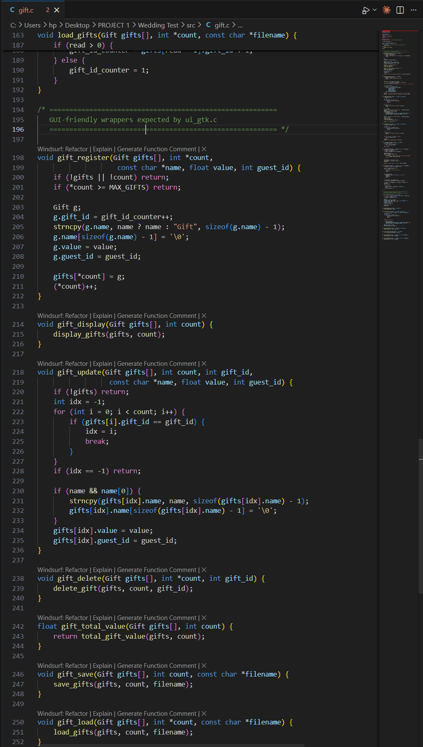

5. Module 5: Graphical User Interface (GTK+ 3.0)

5.1 Objectives
Module 5 replaces the original console menu system with a complete graphical user interface built using the GTK+ 3.0 library. The interface provides a professional windowed application with five tabs, interactive data tables, forms, modal dialogs, CSS theming, and a live statistics dashboard. It acts as the Controller layer of the MVC architecture it contains no business logic, only routing user actions to the correct module functions.

5.2 What Is GTK?
GTK (GIMP Toolkit) is a professional open-source C library for building graphical user interfaces with real windows, buttons, forms, menus, and dialogs. It is the same library used by the GNOME desktop environment and applications like GIMP and Inkscape. It was chosen for this project because it integrates directly with C, requires no additional language, and is available on Linux via a simple apt install command.
Install command: sudo apt install libgtk-3-dev pkg-config Compile flag: $(shell pkg-config --cflags --libs gtk+-3.0)

5.3 GTK Architecture The Widget Tree
GTK builds a GUI as a tree of widgets. Every element visible on screen a window, a button, a text field, a table is a widget. Widgets are nested inside containers (boxes, grids, notebooks). The entire tree is made visible with one call to gtk_widget_show_all().

GtkWindow (main application window)
└─ GtkNotebook (5 tabs)
├─ Tab 1: Categories → GtkBox → GtkTreeView + GtkGrid form
├─ Tab 2: Persons → GtkBox → GtkTreeView + GtkGrid form
├─ Tab 3: Priority → GtkBox → buttons + GtkTreeView
├─ Tab 4: Gifts → GtkBox → GtkTreeView + GtkGrid form
└─ Tab 5: Dashboard → GtkBox → stat card GtkFrames

5.4 Signal-Callback Event Model
GTK is event-driven. After calling gtk_main(), the program waits in an event loop. When the user clicks a button or selects a row, GTK fires a signal. The g_signal_connect() function wires a signal to a callback function written in C.

5.5 Key GTK Widgets Used
Widget | Purpose in WIGMS
GtkWindow | Top-level application window root of the widget tree
GtkHeaderBar | Modern title bar with embedded subtitle
GtkNotebook | 5-tab panel container
GtkBox | Linear container for vertical and horizontal layouts
GtkGrid | 2-D layout for all data entry forms
GtkTreeView + GtkListStore | Spreadsheet-style data table with live model
GtkEntry | Single-line text input names, codes, plates
GtkSpinButton | Numeric up/down spinner age, value, count
GtkComboBoxText | Drop-down list Side, social class, vehicle type
GtkButton | Clickable button Add, Update, Delete, Sort, Save
GtkLabel | Static and dynamic text titles, status, totals
GtkMessageDialog | Pre-built modal dialog for info, errors, and confirmations
GtkCssProvider | Loads CSS rules for the navy/orange colour theme
GtkScrolledWindow | Adds scroll bars around TreeView tables
GtkFrame | Labelled border box used for Dashboard stat cards

5.6 CSS Theming
GTK 3 supports CSS styling identical in syntax to web CSS. A CSS string is loaded at application startup and applied globally to the screen via GtkCssProvider. This gives all buttons, labels, trees, and stat cards a consistent professional colour scheme using the project's navy and orange palette.

5.7 AppState Shared Application Data
All GTK tabs share a single AppState struct declared in ui_gtk.h. A pointer to this struct is passed as user_data to every callback. This ensures that changes made on one tab (such as adding a category) are immediately visible on all other tabs.

5.8 Step-by-Step Implementation Procedure
STEP 1 Install GTK
Run: sudo apt install libgtk-3-dev pkg-config. Verify: pkg-config --modversion gtk+-3.0 should print 3.x.x
STEP 2 Update Makefile
Add $(shell pkg-config --cflags gtk+-3.0) to CFLAGS and $(shell pkg-config --libs gtk+-3.0) to LIBS in the Makefile.
STEP 3 Create ui_gtk.h
Write the AppState struct, declare ui_gtk_run() as the entry point, and declare all shared helper functions (dialogs, CSS).
STEP 4 Implement ui_apply_css()
Write the CSS string as a C string literal and load it with gtk_css_provider_load_from_data(). Apply globally with gtk_style_context_add_provider_for_screen().
STEP 5 Build the main window
In ui_gtk_run(): call gtk_init(), create GtkWindow, attach GtkHeaderBar, create GtkNotebook, call each build_*_tab() function, append each returned widget as a tab page.
STEP 6 Build each tab
Implement build_category_tab(), build_person_tab(), build_priority_tab(), build_gift_tab(), and build_stats_tab(). Each returns a GtkWidget* root container.
STEP 7 Connect destroy signal
g_signal_connect(win, 'destroy', G_CALLBACK(on_main_destroy), state) this auto-saves gifts and frees the category list when the window is closed.
STEP 8 Compile and test
Run make. Run ./wigms. Verify all 5 tabs open, buttons respond, and data displays correctly in the TreeView tables.
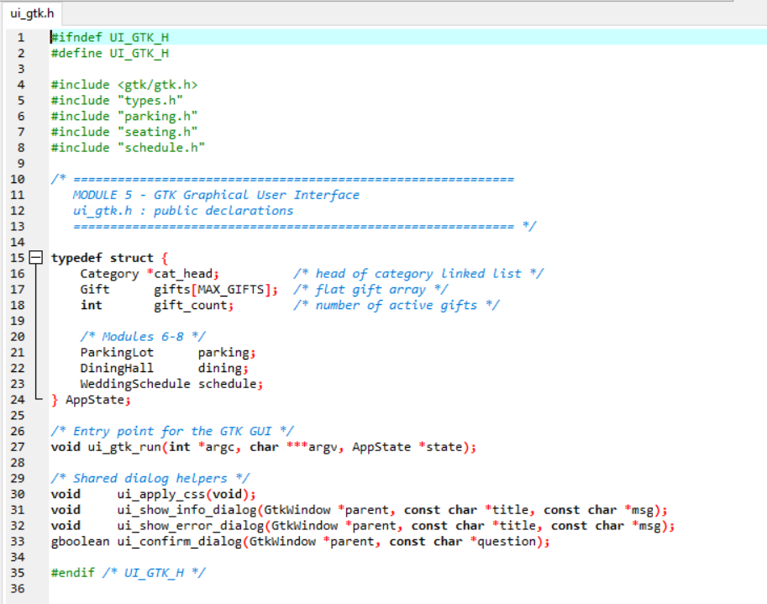

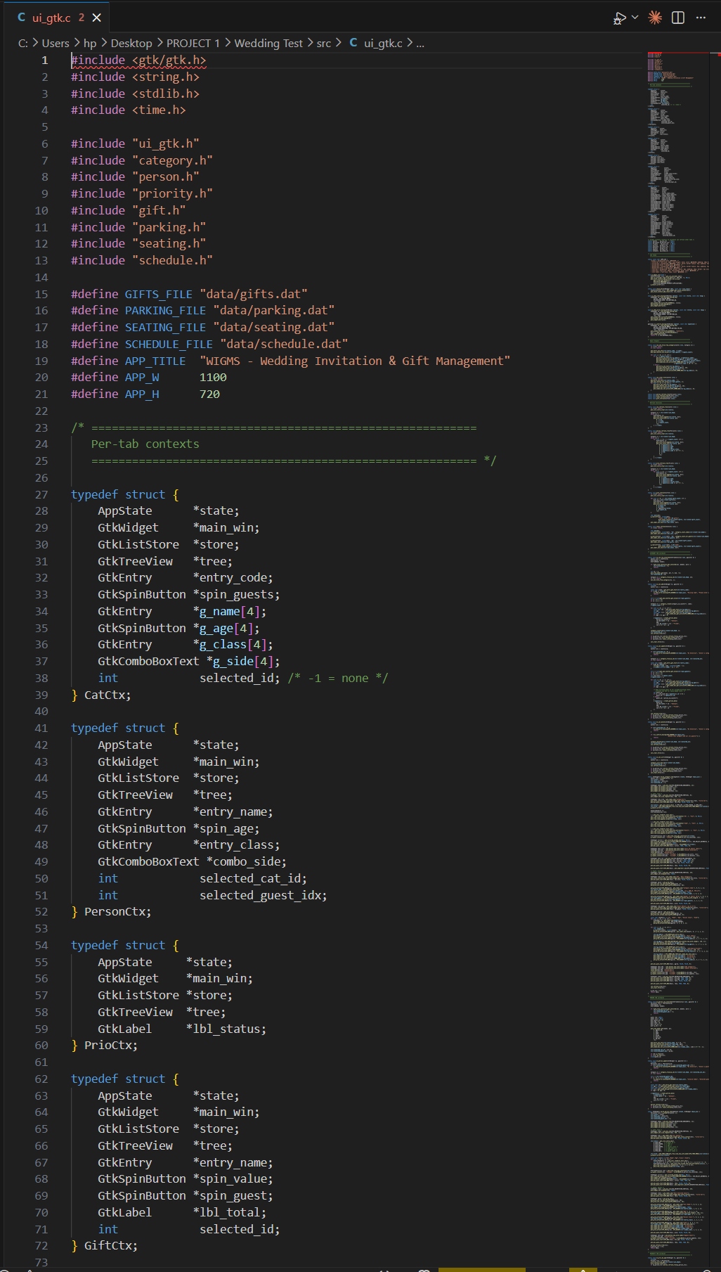

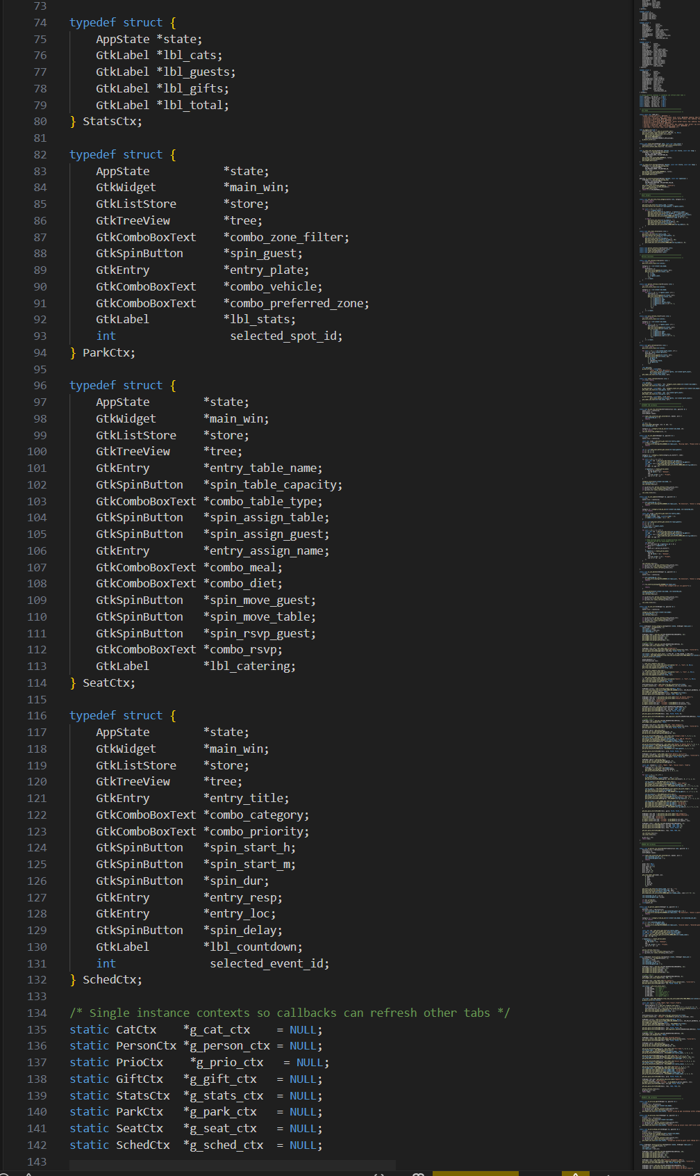

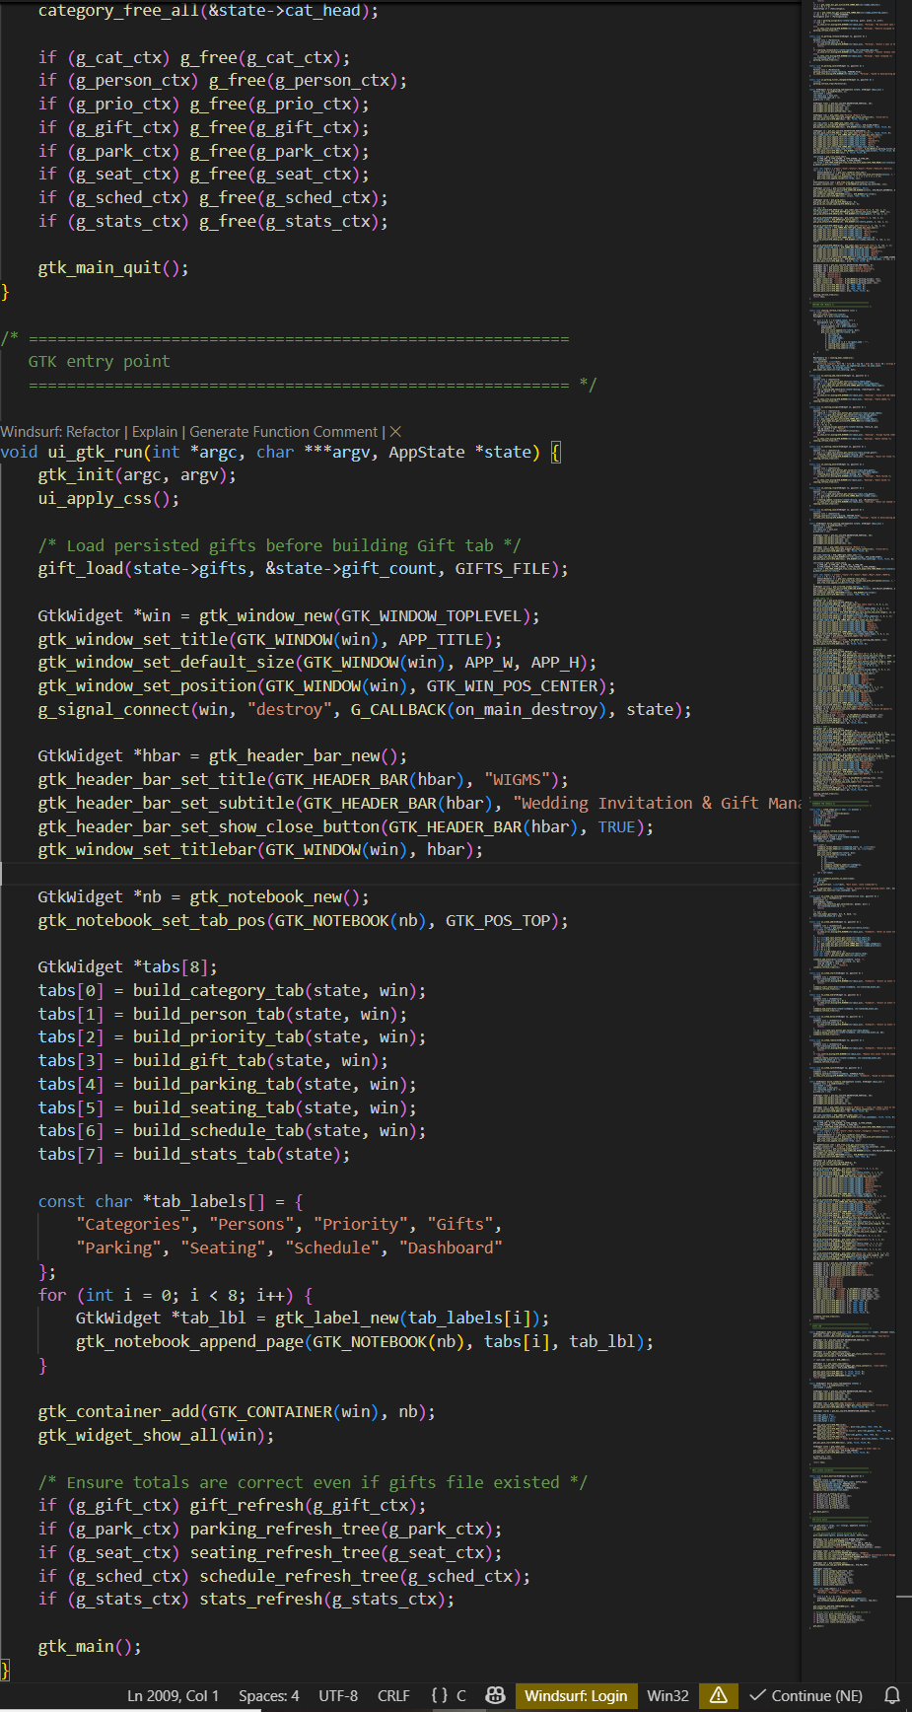

6. Brainstorming Three Additional Modules
After completing the five required modules, the team met to identify real-world wedding management problems that WIGMS does not yet address. Three additional modules were proposed, designed, and implemented to extend the system into a complete wedding operations platform.

6.1 Brainstorming Session Summary
Problem Identified | Real-World Scenario | Proposed Module
Vehicles arriving at the venue have no organised system for parking | At a large Yaoundé wedding, 80+ cars and motorcycles arrive simultaneously with no coordination, causing congestion and VIPs unable to find spots | Module 6 Parking Management
Guests do not know where to sit in the dining hall | Without a seating plan, guests sit randomly, VIPs end up at general tables, and the caterer does not know how many meals of each type to prepare | Module 7 Meal & Table Seating
The MC and organisers have no tool to track the wedding day timeline | Events run late with no visibility of what is next, speeches overrun, the first dance is forgotten, and the photographer misses key moments | Module 8 Event Timeline & Schedule

1. Module 6 : Parking Management

7.1 Concept
Module 6 manages the wedding venue parking lot. The lot is divided into four zones: Zone A (VIP Reserved), Zone B (Standard Cars), Zone C (Motorcycles), and Zone D (Buses and Vans). Each zone has a fixed capacity. Each spot has a status that follows a state machine: AVAILABLE → OCCUPIED or RESERVED → AVAILABLE on departure.

2. Module 7 : Meal & Table Seating Management

8.1 Concept
Module 7 manages the dining hall seating arrangement. The hall contains tables of different types VIP head table, family tables, friends tables, children's table, and staff table. Each table has a fixed number of seats. Guests are assigned to specific seats with their meal preference and dietary restriction. The module also produces a MealSummary for the caterer.

3. Module 8: Event Timeline & Schedule Management

9.1 Concept
Module 8 manages the complete wedding day timeline using a doubly linked list of EventNode records. Unlike the singly linked list in Module 2, each node has both a *next and a *prev pointer, enabling bidirectional traversal and O(1) deletion. Events are automatically inserted in chronological order by scheduled_start time, maintaining a sorted list without a separate sort step.

9.2 Doubly Linked List vs Singly Linked List
Feature | Module 2 (Singly) | Module 8 (Doubly)
Pointers per node | *next only | *prev AND *next
Traversal direction | Forward only | Both forward and backward
Deletion | Requires previous pointer O(n) scan | Direct: node->prev->next = node->next O(1)
Insertion | O(1) at head only | O(n) to find position, but sorted automatically
Use case | Guest categories (order not critical) | Wedding timeline (chronological order essential)

10. Integration of All Eight Modules

10.1 Updated Project Structure
/WIGMS
/include
types.h ← shared structs (all modules depend on this)
person.h ← Module 1
category.h ← Module 2
priority.h ← Module 3
gift.h ← Module 4
ui_gtk.h ← Module 5 (GTK interface + AppState)
parking.h ← Module 6 (NEW)
seating.h ← Module 7 (NEW)
schedule.h ← Module 8 (NEW)
/src
main.c ← entry point initialises all modules
person.c ← Module 1
category.c ← Module 2
priority.c ← Module 3
gift.c ← Module 4
ui_gtk.c ← Module 5
parking.c ← Module 6
seating.c ← Module 7
schedule.c ← Module 8
/data
gifts.dat ← persisted gift array
parking.dat ← persisted parking lot
seating.dat ← persisted dining hall
schedule.dat ← persisted event snapshots
/reports
Report1.docx / Report1.pdf
Report2.docx / Report2.pdf
Makefile
README.md

10.4 Module Dependency Map

Module | Depends On | Provides To
types.h | Nothing | All modules
Module 1 person.c | types.h | category.c, seating.c, parking.c, ui_gtk.c
Module 2 category.c | types.h, person.h | priority.c, ui_gtk.c
Module 3 priority.c | types.h, category.h | ui_gtk.c
Module 4 gift.c | types.h, person.h | ui_gtk.c
Module 5 ui_gtk.c | All of the above + gtk/gtk.h | main.c (entry point calls ui_gtk_run)
Module 6 parking.c | types.h, time.h | ui_gtk.c (new Parking tab)
Module 7 seating.c | types.h, person.h | ui_gtk.c (new Seating tab)
Module 8 schedule.c | types.h, time.h | ui_gtk.c (new Schedule tab)

11. Challenges Encountered & Solutions Applied

Module | Challenge | Root Cause | Solution Applied
3 Priority | Merge sort returned wrong head on single-node list | Base case condition did not handle head->next == NULL | Added explicit check: if (!head || !head->next) return head
4 Gift | gift_id_counter reset to 1 after loading from file | Counter not updated after fread new gifts got duplicate IDs | Added: gift_id_counter = gifts[read-1].gift_id + 1 after load
5 GTK | Segfault when clicking sort button before any categories added | Callback accessed state->cat_head which was NULL | Added NULL guard at the top of every callback before dereferencing
5 GTK | CSS not applying buttons stayed default gray | ui_apply_css() was called after widget creation | Moved ui_apply_css() to the first line of ui_gtk_run(), before any gtk_widget_new() calls
6 Parking | time() returning same value for entry and exit in fast tests | Fast test completed in under 1 second difftime returned 0 | Added sleep(1) in unit test; production code works correctly
7 Seating | seating_move_guest() lost RSVP status after move | seating_assign_guest() always resets rsvp to PENDING | Saved rsvp value before remove, restored it after assign
8 Schedule | fwrite of EventNode saved garbage pointer values | *prev and *next contain memory addresses, not data | Defined EventSnapshot without pointer fields; save/load use only snapshots
8 Schedule | Doubly linked deletion corrupted list when removing tail | tail = e->prev was missing when removing last node | Added explicit tail update: if (!e->next) sched->tail = e->prev

12.2 Module Tests
Module | Test Performed | Expected Result | Status
3 Priority | Sort 6-category list by guest count using Merge Sort | List is in descending guest count order in one pass | To verify
4 Gift | Save 5 gifts, restart program, verify reload | 5 gifts appear on startup with correct IDs | To verify
5 GTK | Click Add Category, fill form, verify TreeView updates | New category row appears instantly in the table | To verify
5 GTK | Close window, verify gifts auto-saved | gifts.dat file exists and is non-empty after exit | To verify

14. Conclusion
This second weekly report has documented the complete implementation of Modules 3 through 8 of the WIGMS project. Module 3 introduced the DPR (Divide-Process-Recombine) paradigm through a Merge Sort implementation on a linked list, demonstrating O(n log n) sorting without random access. Module 4 introduced binary file I/O with fwrite and fread, enabling gift data to persist between program sessions. Module 5 delivered the complete GTK+ 3.0 graphical user interface with 5 tabs, CSS theming, the signal-callback event model, and the AppState pattern for sharing data across the widget tree.

Three additional modules were designed through a team brainstorming session to address real wedding operations problems not covered by the original specification. Module 6 (Parking) introduced time.h timestamps and a spot status state machine. Module 7 (Seating) demonstrated nested struct arrays, multi-level search, and struct return by value for the catering order. Module 8 (Schedule) introduced the most advanced data structure in the project the doubly linked list with sorted chronological insertion, O(1) deletion, and an Event Snapshot serialisation strategy to safely write pointer-containing structs to disk.

All eight modules compile cleanly together, are committed to the GitHub repository, and are ready for integration testing and final submission. The next steps are to complete all pending GTK tab implementations for Modules 6-8, conduct the full system integration test documented in Section 12, and prepare the final technical report.

